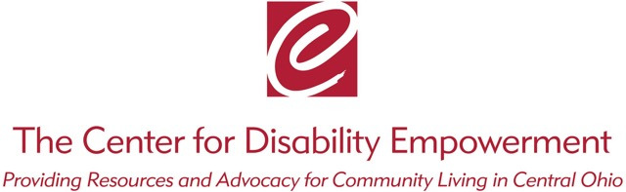
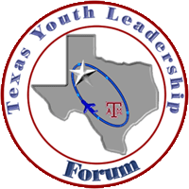

Empower YOUth: Columbus Youth Leadership Forum
August 3-6, 2020
Embassy Suites, 2886 Airport Dr, Columbus, OH 43219
Application Form for Peer Mentors/ Group Facilitators
*No Overnight Stays*

Peer Mentor Job Duties/Requirements:
- Attend all four days of the YLF
- Encourage Delegates to participate within their small groups as well as the large group activities
- Make sure each Delegate is given the opportunity to contribute to group discussion
- Support Delegates who may feel uncomfortable in the new environment

Group Facilitator Job Duties/Requirements:
- Oversee the whole group
- Make sure mentors are engaging with delegates
- Identify the needs of each Delegate within your small group and assigning a volunteer if necessary (i.e. scribe, dictation)
- Keep a daily list of your delegates and making sure they sign in at their table each day
- Assign a mentor to any delegates who you see may need additional support and/or encouragement

Name: ______________________________________________________________
Mailing Address: ______________________________________________________
City: _____________________State:_________________ Zip: _________________
Phone: Home: ______________________ Work:_____________________________
Email:_______________________________________________________________

Position Desired:
______Small/Large Group Facilitator
______Mentor/Peer Facilitator

Description of Disability: ________________________________________________________

List any reasonable accommodations you would require on site: ________________________________________________________________________________________________________________________________________________________________________________________________________________________________________________________________________________________________________________Explain your experience working with people with disabilities, including YLF experiences: ____________________________________________________________________________
____________________________________________________________________________
____________________________________________________________________________________________________________________________________________________________________________________________________________________________________________________________________________________________________________________________________________________________________________________________________________________________________________________________________________________________________________________________________________________

Mentors and Facilitators will be required to attend a mandatory Mentor/Facilitator training prior to the weekend event.

I understand the requirements of the position for which I am applying. I also understand the commitment to participate for the entire session and that I will be required to for the entire Forum and attend all mentor and facilitator meetings. I understand that along with the rest of the Forum staff volunteers I am responsible for the supervision of the student delegates and am legally responsible for my actions while at the Forum. I understand that I am responsible for my actions and do not hold YLF for those actions or the ramifications of those actions.

Signature _______________________________ Date _______/_____/______

Return completed applications to: Jamie Lahrmer by mail at The Center for Disability Empowerment located at 510 E. North Broadway, 4th Floor, Columbus, OH 43214 or via email at jlahmer.cde@gmail.com. Any questions can also be directed to Jamie via phone at (614) 575-8055.
